OpenStack Cloud Automation Documentation
By – Team AIML-015

Table of Contents

- Introduction
  - Overview of OpenStack
  - Purpose of the Automation Script
  - Key Features of the Script

- Prerequisites
  - Software Requirements
  - OpenStack Configuration
  - Authentication Details

- System Overview
  - Architecture of the OpenStack Cloud Setup
  - Description of the Modules
  - Workflow Diagram

- Installation Guide
  - Setting up OpenStack API Connection
  - Installing Python Dependencies
  - API Authentication Setup

- Authentication with OpenStack
  - Overview of Keystone Authentication
  - Generating the Authentication Token
  - Common Errors in Authentication

- Core Functionalities
  - Creating Virtual Machines (VMs)
    - Description of VM Creation
    - Function Details (create_vm)
    - Example Requests
  - Creating Networks
    - Description of Network Creation
    - Function Details (create_network)
    - Example Requests
  - Creating Volumes
    - Description of Volume Creation
    - Function Details (create_volume)
    - Example Requests
  - VM Deletion
    - Deleting VMs
    - Function Details (delete_vm)
    - Example Requests
- Advanced Features
  - Querying Project Usage
    - Understanding Resource Usage
    - Function Details (project_usage)
    - Example Requests

  - NLP Integration for Intent Parsing
    - Overview of NLP Implementation
    - Parsing User Requests
    - Example Requests and Responses

- Error Handling
  - Common API Errors
  - Error Handling in the Script
  - Troubleshooting Tips

- Extending the Script
  - How to Add New Features
  - Customizing the Script for Specific Needs
  - Example of Adding New Intent

- Conclusion
  - Summary of Features
  - Future Improvements

1. Introduction
Overview of OpenStack
OpenStack is an open-source platform used for building and managing public and private clouds. It provides a set of software tools for building and managing cloud computing platforms for public and private clouds. The system supports various cloud infrastructure services such as Compute, Storage, and Networking.
Purpose of the Automation Script
The automation script provided is designed to streamline common OpenStack operations such as creating VMs, networks, volumes, and querying resource usage through an NLP-powered interface. The script handles these tasks by interacting with OpenStack's APIs programmatically, reducing manual intervention.
Key Features of the Script
- NLP Integration: Automatically detects user intentions (e.g., creating VMs, networks, etc.) from input text.
- Cloud Operations: Automates the creation and deletion of VMs, networks, and volumes in OpenStack.
- Authentication: Secure token-based authentication for OpenStack APIs.
- Error Handling: Handles common errors related to OpenStack API interactions.

2. Prerequisites
Software Requirements
- Python 3.x: The script is written in Python 3 and requires Python version 3.6 or higher.
- Libraries:
  - requests for making API calls to OpenStack.
  - spacy for NLP processing to handle user input.
  - openstack SDK for OpenStack API interactions.

OpenStack Configuration
The script interacts with several OpenStack services such as Compute (Nova), Networking, and Block Storage (Cinder). Ensure that these services are up and running, and the URLs in the script (NOVA_URL, KEYSTONE_URL, etc.) are configured correctly.

Authentication Details
Before running the script, ensure you have the following credentials:
- Username and Password for OpenStack authentication.
- Project Name and Domain Name.

3. System Overview
Architecture of the OpenStack Cloud Setup
The script interfaces with OpenStack via several APIs:
- Keystone API: Used for authenticating and obtaining an authentication token.
- Nova API: Manages virtual machines (VMs) and computes resources.
- Cinder API: Manages storage volumes.
- Neutron API: Handles networking components like networks and subnets.
- Glance API: Manages images used to launch VMs.
Description of the Modules
- Authentication Module: Handles the authentication and token management.
- VM Management: Functions to create, delete, and list virtual machines.
- Network Management: Functions for creating and managing networks.
- Volume Management: Functions to create and manage storage volumes.
- NLP Integration: Processes user input and maps it to corresponding cloud tasks.

4. Installation Guide
Setting up OpenStack API Connection
To connect to OpenStack, you need to configure the URLs for the relevant OpenStack services (Nova, Keystone, Cinder, etc.) and provide authentication credentials. These configurations can be set in the script itself.
Installing Python Dependencies
Install the required Python libraries using the following command:
bash
pip install requests spacy openstack
API Authentication Setup
To authenticate with OpenStack, ensure that your username, password, project name, and domain name are correctly set in the script. The get_auth_token function uses these credentials to authenticate and retrieve a token.

5. Authentication with OpenStack
Overview of Keystone Authentication
Keystone is the identity service in OpenStack that provides authentication and authorization services. The script uses password-based authentication to get an auth token.
Generating the Authentication Token
The script sends a request to the Keystone API to authenticate the user and return a token, which is used for subsequent API calls.
Common Errors in Authentication
- Invalid Credentials: Ensure that the username, password, project name, and domain name are correct.
- Token Expiry: Tokens have a limited lifespan. Ensure that the token is valid before using it.

6. Core Functionalities
Creating Virtual Machines (VMs)
Description of VM Creation
A VM is created using the create_vm function. This function requires the following parameters:
- Name of the VM.
- Flavor: Specifies the compute resources (CPU, RAM) of the VM.
- Image: The image to be used for the VM (could be specified by name or ID).
Example Requests
python
create_vm("my-vm", "m1.small", "ubuntu-image")
Creating Networks
Description of Network Creation
Network creation is handled by the create_network function. This function will create a network and an associated subnet.
Example Requests
python
create_network(conn, "my-network")
Creating Volumes
Description of Volume Creation
Volumes are storage devices that can be attached to VMs. The create_volume function handles the creation of volumes.
Example Requests
python
create_volume(conn, "my-volume", 50)
VM Deletion
Description of VM Deletion
The delete_vm function deletes a virtual machine by its name.
Example Requests
python
delete_vm("my-vm", auth_token)

7. Advanced Features
Querying Project Usage
The project_usage function queries the usage of resources (vCPUs, RAM, GPUs, and storage) in the project.
Example Requests
python
project_usage(conn)
NLP Integration for Intent Parsing
The script uses the spaCy library to parse natural language input and map it to cloud-related actions (create a VM, create a network, etc.).
Example Requests
python
process_user_input("Create a VM named my-vm with flavor m1.small")

8. Error Handling
The script includes robust error handling to manage common API issues such as invalid credentials, missing parameters, and network errors. Each function prints detailed error messages when an operation fails.

9. Extending the Script
To add new features:
- Define new intents in the parse_intent function.
- Implement the corresponding OpenStack API calls in the relevant function.
- Update the main function to process the new intent.
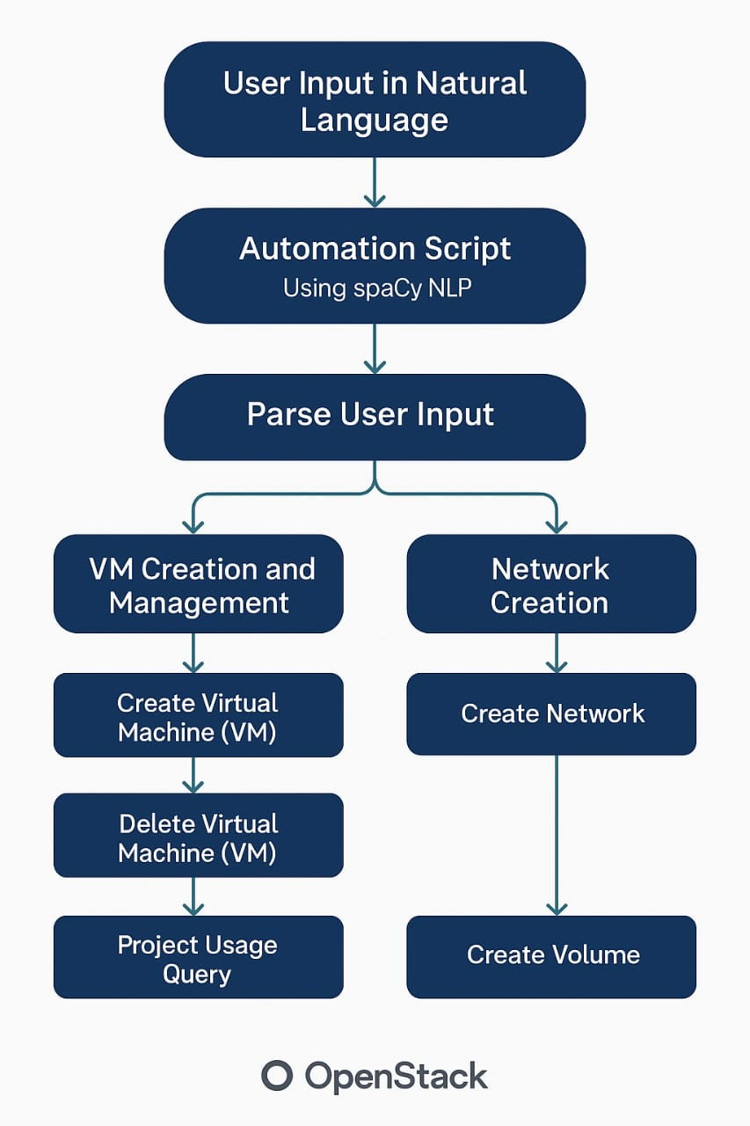

For instance, a user might simply type "Create a VM named my-vm with flavor m1.small", and the script will understand this intent, identify the necessary parameters (VM name and flavor), and trigger the creation of the VM. Similarly, users can issue commands such as "Create a network named my-network" or "Create a volume called my-volume with size 50GB", and the script will handle the API interactions, eliminating the need for users to know the exact API calls or configurations required.
This natural language interface significantly enhances accessibility, allowing non-technical users, or those with limited knowledge of cloud infrastructure, to perform complex cloud tasks with ease. It also reduces human error, as the system guides users to input the correct parameters, ensuring that resource creation is done correctly.
10. Conclusion
What makes this script stand out is its integration with Natural Language Processing (NLP) capabilities. Using the spaCy NLP library, the script parses and interprets user input expressed in natural language, transforming vague or ambiguous requests into specific OpenStack operations. This lowers the barrier to entry for users who may not be familiar with OpenStack's technical jargon or API endpoints.

